EXPERIMENT-1

AIM :- Create a Web Page for Course Curriculum: Use of Headings, Paragraphs, Bold, Italic, Underline, and Special Characters, Ordered List, Unordered List, Description List, Nested List, and Mixed Lists.

Objectives
1. To design a simple course curriculum webpage using HTML.
2. To practice the use of basic text formatting tags (bold, italic, underline, special characters).
3. To learn the implementation of ordered, unordered, description, nested, and mixed lists.
4. To understand webpage content structuring using headings and paragraphs.

Tools Required
• Computer / Laptop with any OS
• Text Editor (VS Code, Sublime Text, Notepad++)
• Web Browser (Chrome, Edge, Firefox)

Theory
1. Headings (<h1>…<h6>): Used to display titles and subheadings in different sizes.
2. Paragraphs (<p>): Defines blocks of text content.
3. Formatting Tags:
o <b> for bold text
o <i> for italic text
o <u> for <u>underlined text</u>
o Special characters are displayed using HTML entities (e.g., ©, <, >).
4. Lists:
o Ordered List (<ol>): Numbered items.
o Unordered List (<ul>): Bulleted items.
o Description List (<dl>): Term and description pairs.
o Nested List: A list inside another list.
o Mixed List: Combination of ordered, unordered, and nested lists.Code

Implementation
<!DOCTYPE html>
<html lang="en">
<head>
<meta charset="UTF-8">
<meta name="viewport" content="width=device-width, initial-scale=1.0">
<title>HTML</title>
</head>
<body>
<h2>Introduction</h2>
<ul>
<li>Welcome to the course curriculum. This page demonstrated the use of HTML formatting,lists and special characters such as <,>,</li>
<h5>Semester 1 Subjects(Ordered List)</h5>
<ul> <li>1.Mathematics I</li>
<li>2.Computer Fundamentals</li>
<li>3.Programming in C</li>
<li>4.Electronics Basics</li>
</ul>
<h5>Programming Languages(unordered list)</h5>
<ul> <li>C</li>
<li>JAVA</li>
<li>PYTHON</li>
<li>JAVA SCRIPT</li>
</ul>
<h5>Course Description(Description List)</h5>
<ul>C Programming
<li>learn basics of C language including loops,arrays,and functions</li>
</ul>
<ul>Java
<li>introduction to Object-oriented Programming concepts.</li>
</ul>
<h5>Course Modules(Nested List)</h5>
<ul>1.Module 1:Basics
<li>Introduction</li>
<li>History of Computers</li>
</ul>
<ul>2.Modules 2:Programming
<li>Variables&Data types</li>
<li>Control Statements</li>
</ul>
<h5>Project Work(Mixed List)</h5>
<ul>Web Development
<li>1.HTML</li>
<li>2.CSS</li>
<li>3.Java Script</li>
</ul>
<ul>Data Base
<li>A.MYSQL</li>
<li>B.MongoDB</li>
</ul>
<p>vartika rastogi</p>
<p>2025B02310083</p>
<p>ELCE-2</p>

</body>
</html>

OUTPUT:-
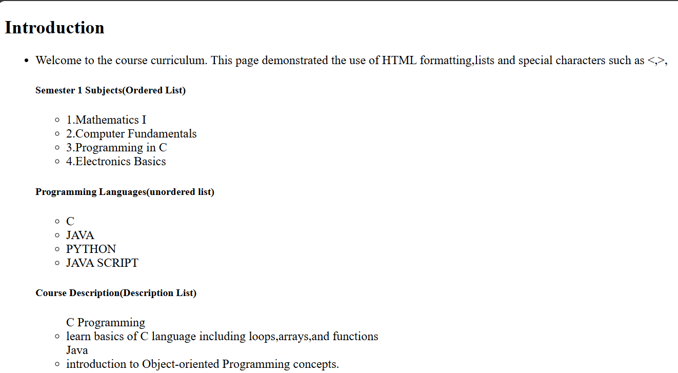

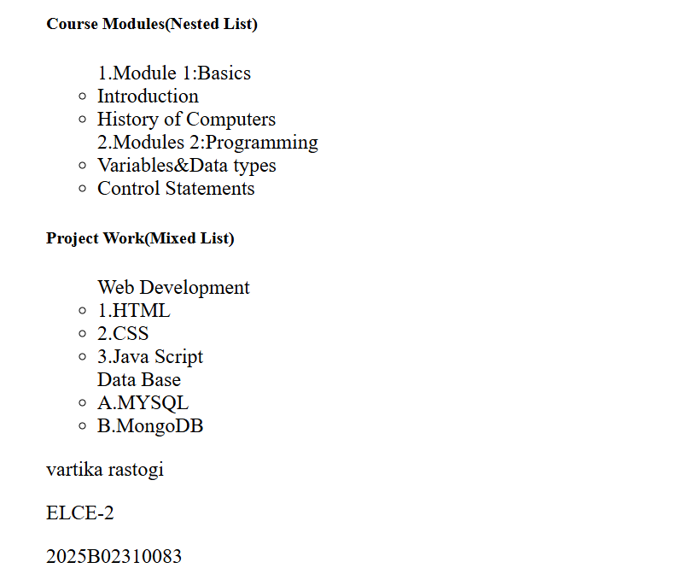

EXPERIMENT-2

AIM- Create a Web Page for a News Website with Embedded YouTube Video, Hyperlinks, and Navigation Structure, and Insert Multimedia in a Webpage.

Objectives
1. To design a simple news website homepage using HTML and CSS.
2. To learn how to embed YouTube videos into a webpage.
3. To implement hyperlinks and navigation menus for easy browsing.
4. To insert multimedia (images, videos, audio) in a webpage.

Tools Required
• Computer / Laptop with any OS
• Text Editor (VS Code, Sublime Text, Notepad++)
• Web Browser (Chrome, Edge, Firefox)
• Internet connection (for YouTube embedding)

Theory
1. Hyperlinks (<a> tag):
Hyperlinks allow navigation between pages or websites. Example:
<a href="https://www.bbc.com">Visit BBC News</a>
2. Navigation Structure:
A <nav> element groups navigation links for better structure.
3. Embedding YouTube Video:
YouTube provides an <iframe> code for embedding videos into a webpage.
<iframe src="https://www.youtube.com/embed/VIDEO_ID"></iframe>
4. Multimedia in Webpages:
o Image (<img>): Display news images.
o Audio (<audio>): Add podcasts or news audio clips.
o Video (<video>): Insert local or hosted video files.

Code Implementation:-
<!DOCTYPE html>
<html lang="en">
<head>
<meta charset="UTF-8">
<meta name="viewport" content="width=device-width, initial-scale=1.0">
<title>Multimedia</title>
</head>
<body>
<h1 align="center">Global Daily News</h1>
<p align="center">Your trusted source for daily news</p>
<hr>
<nav align="center">
<a href="#">World</a>&nbsp;|&nbsp;
<a href="#">Sports</a>&nbsp;|&nbsp;
<a href="#">Entertainment</a>&nbsp;|&nbsp;
<a href="#">Podcast</a>&nbsp;|&nbsp;
<a href="#">Contact</a>
</nav>
<hr>
<p>World News<br><br>Today's top headline: Global leaders meet to discuss climate change initiatives.</p>
<img src="bbc.png" alt="error" width="550" height="350"><br>
<a href="https://www.bbc.com/future/article/20250930-beyond-carbon-footprints-the-science-of-the-most-impactful-climate-actions" target="_blank">Read more on BBC</a><br>
<hr>
<p><h2>Sports Update</h2>Highlights of yesterday's foot ball match with thrilling last-minute goals!</p><br>
<iframe width="560" height="315" src="https://www.youtube.com/embed/TzpGHKRBajQ?si=aAI_d6o1kofaXWif" title="YouTube video player" frameborder="0" allow="accelerometer; autoplay; clipboard-write; encrypted-media; gyroscope; picture-in-picture; web-share" referrerpolicy="strict-origin-when-cross-origin" allowfullscreen></iframe>
<hr>
<p><h2>Entertainment Buzz</h2>New movie trailer released today. Fans are exited!</p>
<video controls width="560" height="315">
<source src="earth.mp4" type="video/mp4">
</video>
<hr>
<p><h2>News Podcast</h2>Listen to today's top headlines:</p>
<audio controls>
<source src="GlobalNewsPodcast.mp3" type="audio/mp3">
</audio>
<hr>
<p><h2>Contact Us</h2>Email: info@globalnews.com<br>&copy; 2025 Global Daily News</p>
<p>Name: vartika’s html</p>
<p>ELCE-2</p>
</body>
</html>

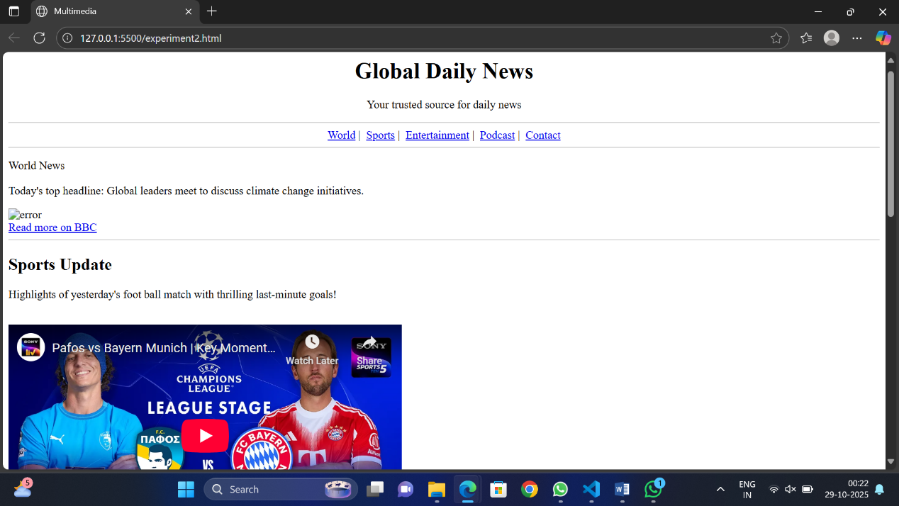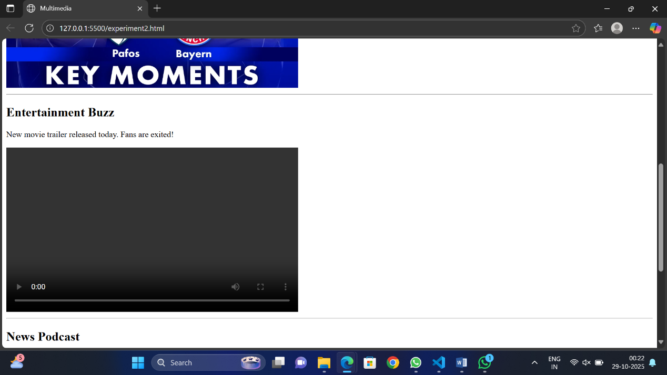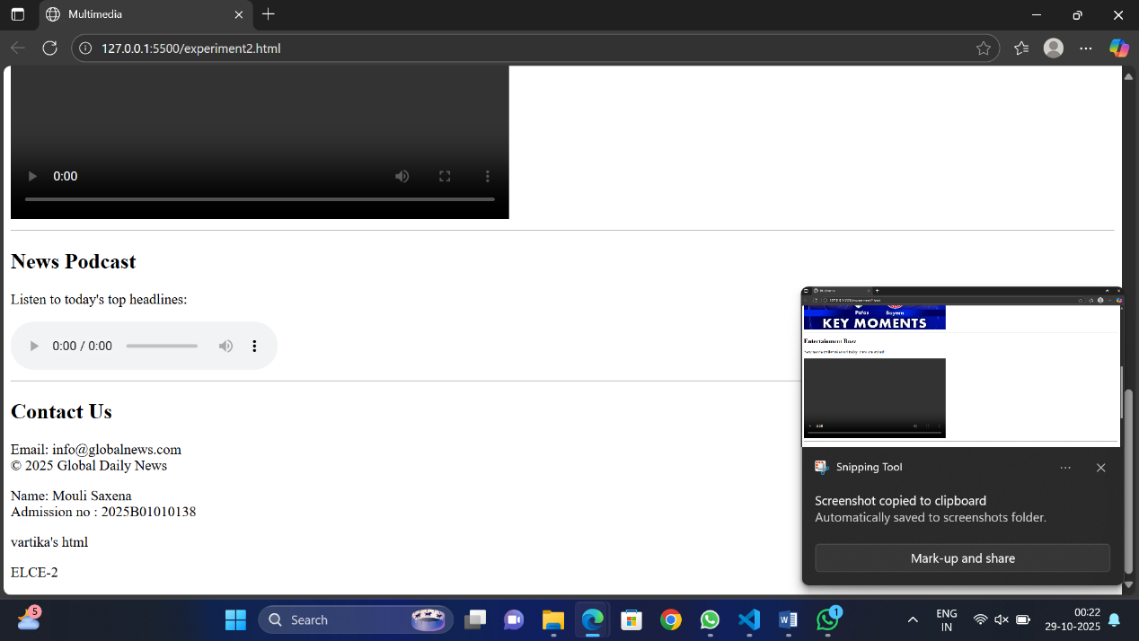

EXPERIMENT-3

AIM:- Create a Web Page for College Timetable: Use of Tables with Rowspan, Colspan, Headers, Captions, and Nested Tables.

Objectives
1. To design a college timetable webpage using HTML tables.
2. To apply rowspan and colspan attributes for merging cells.
3. To use table headers (<th>), captions (<caption>), and formatting for readability.
4. To implement nested tables within a timetable cell.

Tools Required
• Computer / Laptop with any OS
• Text Editor (Notepad, VS Code, Sublime Text)
• Web Browser (Chrome, Edge, Firefox)

Theory
1. Table (<table>): Arranges data in rows and columns.
2. Rowspan: Merges a cell vertically across rows.
3. <td rowspan="2">Lab</td>
4. Colspan: Merges a cell horizontally across columns.
5. <td colspan="3">Break</td>
6. Header (<th>): Displays header cells in bold and centered.
7. Caption (<caption>): Defines the title of the table.
8. Nested Table: A table placed inside another table cell.

Code Implementation:-
<!DOCTYPE html>
<html lang="en">
<head>
<meta charset="UTF-8">
<meta name="viewport" content="width=device-width, initial-scale=1.0">
<title>LECTURE 3</title>
</head>
<body>
<!DOCTYPE html>
<html lang="en">
<head>
<meta charset="UTF-8">
<meta name="viewport" content="width=device-width, initial-scale=1.0">
<title>Document</title>
</head>
<body>
<table border="1" cellspacing="0" cellpadding="5">
<tr>
<th>periods</th>
<th>1</th>
<th>2</th>
<th>3</th>
<th>4</th>
<th>5</th>
<th rowspan="7">lunch</th>
<th>6</th>
<th>7</th>
<th>8</th>
</tr>
<tr>
<th>TIME</th>
<th>8:00-9:00</th>
<th>9:00-10:00</th>
<th>10:00-11:00</th>
<th>11:00-12:00</th>
<th>12:00-1:00</th>
<th>1:00-2:00</th>
<th>2:00-3:00</th>
<th>3:00-4:00</th>

</tr>
<tr>
<td>monday</td>
<td>DSA</td>
<td>DSA</td>
<td>Electronics</td>
<td>Maths</td>
<td>Soft skills</td>
<td>Mechanical</td>
<td>Mathematics</td>
<td>Mentor mentee</td>
</tr>
<tr>
<td>tuesday</td>
<td>Electronic</td>
<td>Electronics</td>
<td>DSA</td>
<td>DSA</td>
<td>Design thinking</td>
<td>Mech</td>
<td>Maths</td>
<td>Electronics</td>
</tr>
<tr>
<td>Wednesday</td>
<td>Electronic</td>
<td>Maths</td>
<td>Mech</td>
<td>web design</td>
<td >DESIGN THINKING</td>
<td rowspan="1" colspan="2">
<table border="1" cellspacing="0" cellpadding="4" width="100%">
<tr>
<th colspan="2">DSA</th>
</tr>
<tr>
<td>G1</td>
<td>lab 29</td>
</tr>
<tr>
<td>G2</td>
<td>lab 30</td>
</tr>
</table>
</td>

</tr>
<tr>
<td>Thursday</td>
<td>MATHS</td>
<td>mechanical</td>
<td>SOFT SKILL</td>
<td >DESIGN THINKING</td>
<td>MATHS</td>
<td colspan="2">WEB DEV</td>
<td>ELECTRONICS</td>
</tr>
<tr>
<td>Friday</td>
<td>MATHS</td>
<td>DSA</td>
<td>maths</td>

<td>MATHS</td>
<td>WEB Dev</td>
<td colspan="2">ELECTRONICS</td>
<td>dsa</td>
</tr>
</table>

</body>
</html>

</body>
</html>
OUTPUT:-
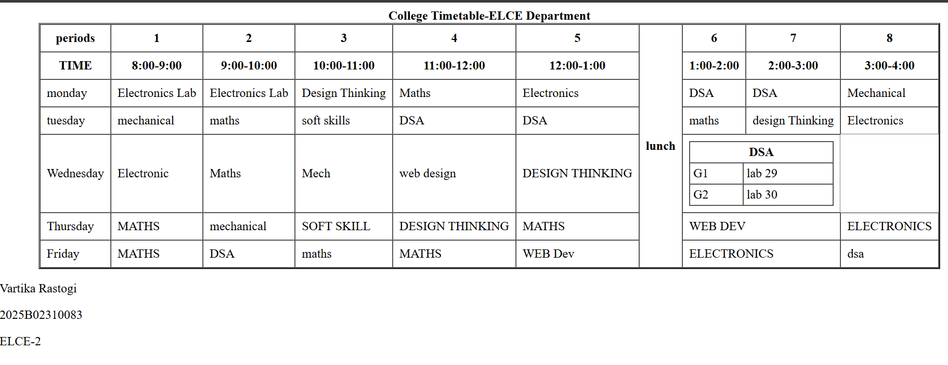

EXPERIMENT-4

AIM:- Create Web page for Hotel room booking form: Use of input fields, labels, select, textarea, and buttons.

Objectives
1. To design a hotel room booking form using HTML.
2. To understand the use of input fields for collecting user details.
3. To apply labels for form accessibility.
4. To implement dropdown menus (select) and text areas.
5. To create functional buttons for form submission and reset.

Tools Required
• Computer / Laptop with any OS
• Text Editor (Notepad, VS Code, Sublime Text)
• Web Browser (Chrome, Edge, Firefox)

Theory
1. Form (<form>): Defines a section for user input.
2. Input Fields (<input>): Used for text, numbers, emails, dates, etc.
3. <input type="text" name="username">
4. Labels (<label>): Connects text with form elements for better usability.
5. <label for="name">Name:</label>
6. Select (<select>): Provides a dropdown menu.
7. <select><option>Single</option><option>Double</option></select>
8. Textarea (<textarea>): Allows multi-line text input.
9. Buttons (<button> or <input type="submit">): Used for form submission or reset.

Code Implementation
<!DOCTYPE html>
<html lang="en">
<head>
<meta charset="UTF-8">
<meta name="viewport" content="width=device-width, initial-scale=1.0">
<title>Document</title>
</head>
<body>
<center>
<h1>Hotel Room Booking Form</h1>

<form>
<label>Full Name:</label>
<input type="text" name="full name"><br><br>

<label>Email:</label>
<input type="email" name="email"><br><br>

<label>Phone:</label>
<input type="phone" name="phone"><br><br>

<label>Check-in Date:</label>
<input type="date" name="checkin date"><br><br>

<label>Check-out Date:</label>
<input type="date" name="checkout date"><br><br>

<label>Room Type:</label>
<select name="room type">
<option value="single">Single Room</option>
<option value="double">Double Room</option>
<option value="suite">Suite</option>
<option value="deluxe">Deluxe Room</option>
</select><br><br>

<label>Number of Guests:</label>
<input type="number" name="guests"><br><br>

<label>Special Requests:</label><br>
<textarea name="special requests"></textarea><br><br>

<button type="submit">Book Now</button>
<button type="reset">Reset Form</button>
</form>
</center>
</body>
</html>
OUTPUT:-

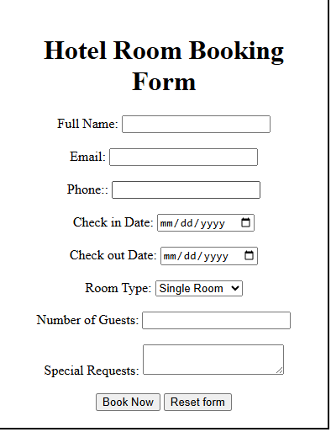

EXPERIMENT - 5

AIM:- Create a Web Page for Student Registration Form with Email Validation by applying form attributes (method, action, placeholder, required).

Objectives
1. To design a student registration form using HTML.
2. To apply form attributes:
• method → Defines how data is sent.
• action → Defines where data is sent.
• placeholder → Displays hint text.
• required → Ensures mandatory fields are filled.
- To implement basic email validation using the type="email" attribute.

Tools Required
• Text Editor (Notepad, VS Code, Sublime Text)
• Web Browser (Chrome, Edge, Firefox)

Theory
• HTML Forms (<form>): Used to collect user input.
• Form Attributes:
• method="post" → Sends form data securely.
• action="submit.html" → Defines where the form data goes (dummy page here).
• placeholder="Enter Name" → Shows hint text inside input box.
• required → Makes the field compulsory.
• Email Validation:
• type="email" → Ensures user enters data in email format (e.g., abc@example.com).

Code Implementation:-
<!DOCTYPE html>
<html lang="en">
<head>
<meta charset="UTF-8">
<meta name="viewport" content="width=device-width, initial-scale=1.0">
<title>Document</title>
</head>
<body>
<center>

<h1>Student Registration Form</h1>
</center>
<form> <fieldset style="width=50%;">

<label>Full Name:</label>
<input type="text" placeholder=" Enter your full name"><br><br>

<label>Email:</label>
<input type="email" placeholder="Enter valid email address"><br><br>

<label>Password:</label>
<input type="password" placeholder="Enter password"><br><br>

<label>Gender:</label>
<input type="radio" placeholder="gender">Male
<input type="radio" placeholder="gender">Female
<input type="radio" placeholder="gender">Other<br><br>
label>Course:</label>
<select>
<option>Select Course</option>
<option>B.Tech</option>
<option>BCA</option>
<option>B.Sc</option>
</select><br><br>

<label>Contact No:</label>
<input type="text" placeholder="Enter phone number"><br><br>

<label>Address:</label><br>
<textarea placeholder="Enter your address"></textarea><br><br>

<input type="submit" value="Register">
<input type="reset" value="Clear">

</form>
<center> <p>&copy; 2025 Student Registration Portal</p>
</center>
</fieldset>

</body>
</html>

OUTPUT:-
